17.117: The rate at which the helium evaporates is the heat gained from the surroundings by radiation divided by the heat of vaporization. The heat gained from the surroundings come from both the side and the ends of the cylinder, and so the rate at which the mass is lost is
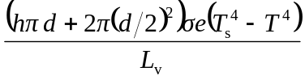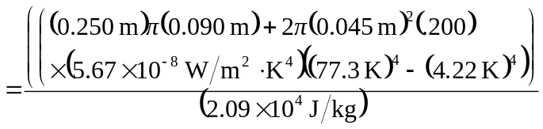
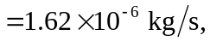
which is 